Aimee Steinwand
BIOS 6624
Project 3 Final Report
Introduction
This analysis uses data from the Framingham Heart Study, a landmark prospective cohort study initiated in 1948 to investigate the etiology of cardiovascular disease. The dataset provided includes clinic, laboratory, questionnaire, and event data on 4,434 participants collected across three examination periods spanning approximately 1956 to 1968. The primary aim of this analysis is to identify key baseline risk factors associated with stroke incidence and to estimate the 10-year survival probability of stroke under various clinical risk profiles, with all analyses stratified by sex.
The statistical hypothesis of interest is that systolic blood pressure, age, diabetes status, and smoking are independently associated with time to stroke, evaluated using sex-stratified Cox proportional hazards models. Specifically, we test whether the hazard ratio for each risk factor is significantly different from 1.0 at α = 0.05, and whether the pattern of associations differs between male and female models.
Methods
Data Management
Data included 4,434 participants across three examination periods. Prior to analysis, participants who had experienced a stroke at baseline (time to stroke = 0 at Period 1) were excluded, as the scientific question of interest concerns time to first stroke among stroke-free individuals. Follow-up was administratively censored at 10 years (3,652.5 days) to evaluate risk more closely related to the baseline risk factor measurements. Participants who experienced a stroke after 10 years were treated as censored at 3,652.5 days. Only baseline covariates from Period 1 were used in the primary analysis, to avoid the complexity of time-varying covariates.
Candidate risk factors evaluated for inclusion included systolic blood pressure, age, diabetes status, current smoking status, and antihypertensive medication use (BP medication). All variables were assessed for missing values and implausible values prior to analysis. BP medication had 60 missing values and was handled via complete case analysis. No implausible values were identified for systolic blood pressure or age. The binary stroke event indicator and continuous survival time variables were derived from the event data, censored as described above.
Preliminary Analysis
Baseline characteristics of the analytic sample were summarized overall and stratified by sex using means and standard deviations for continuous variables and counts and percentages for categorical variables shown in Table 1. Unadjusted survival curves were estimated using the Kaplan-Meier method, stratified by sex, to characterize the overall pattern of stroke-free survival over the 10-year follow-up period.
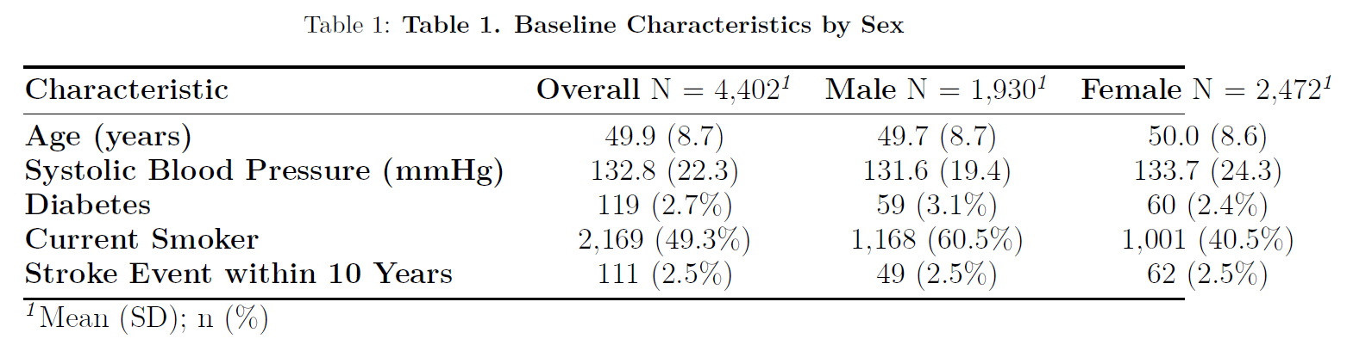
To inform variable selection, Kaplan-Meier curves were also produced for each candidate risk factor using clinically meaningful dichotomizations. Variables demonstrating meaningful separation in unadjusted survival curves were considered for inclusion in multivariable modeling (Appendix).
Primary Analysis
Sex-stratified Cox proportional hazards models were used to evaluate the association between baseline risk factors and time to first stroke. Separate models were fit for male and female participants to allow for potentially different risk factor effects by sex, while also facilitating direct comparison between groups. The outcome variable was time to first stroke in days, censored at 3,652.5 days.
Model selection was performed using bidirectional stepwise selection based on the Akaike Information Criterion (AIC), with systolic blood pressure, age, and diabetes status forced into the model as covariates of primary clinical interest per investigator specification. BP medication was included in the full candidate model but was removed by the stepwise procedure in both the male and female models, suggesting it did not contribute meaningfully to model fit beyond the other covariates, which is biologically plausible given its collinearity with systolic blood pressure. Current smoking status was subsequently added to both final models to support clinically meaningful risk profile comparisons. The final models for both sexes included systolic blood pressure, age, diabetes status, and current smoking status.
The proportional hazards assumption was assessed for each covariate using Schoenfeld residuals and formal tests. Diabetes status showed evidence of a potential violation of the proportional hazards assumption, suggesting its effect on stroke risk may not be constant over the 10-year follow-up period. This variable was retained in the model given its clinical importance, however, this finding is noted as a limitation and results involving diabetes should be interpreted with caution.
Hazard ratios and 95% confidence intervals were estimated for each covariate in the final models (Appendix). Statistical significance was evaluated at α = 0.05. Ten-year stroke-free survival probabilities were estimated from each sex-specific model for clinically relevant risk profiles across ages 40, 50, and 60, including an average profile, high systolic blood pressure (160 mmHg), diabetes, combined high blood pressure and diabetes, and current smoker, as shown in Table 2.
Secondary Analysis
To characterize change in risk factors across the three examination periods, descriptive statistics were computed for all final model covariates across Periods 1, 2, and 3 using the full unadjusted dataset. Continuous variables were compared across periods using a one-way analysis of variance and categorical variables were compared using Pearson's chi-squared test, both evaluated at α = 0.05, shown in Table 3. This analysis was conducted using all available observations across periods rather than the censored analytic sample, as its purpose is purely descriptive and intended to inform whether a time-varying covariate analysis may be warranted in future work.
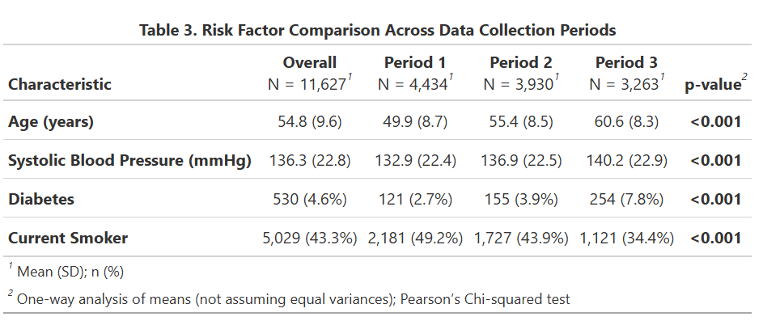

Results
Descriptive Statistics
The analytic sample included 4,402 stroke-free participants at baseline, of whom 1,930 (43.8%) were male and 2,472 (56.2%) were female (Table 1). Mean age was similar between sexes (49.7 years in males, 50.0 years in females), as was mean systolic blood pressure (131.6 mmHg in males, 133.7 mmHg in females). Diabetes was present in 3.1% of males and 2.4% of females. Current smoking was notably higher in males (60.5%) compared to females (40.5%). Over the 10-year follow-up period, stroke events occurred in 49 males (2.5%) and 62 females (2.5%), for an overall stroke incidence of 2.5%.
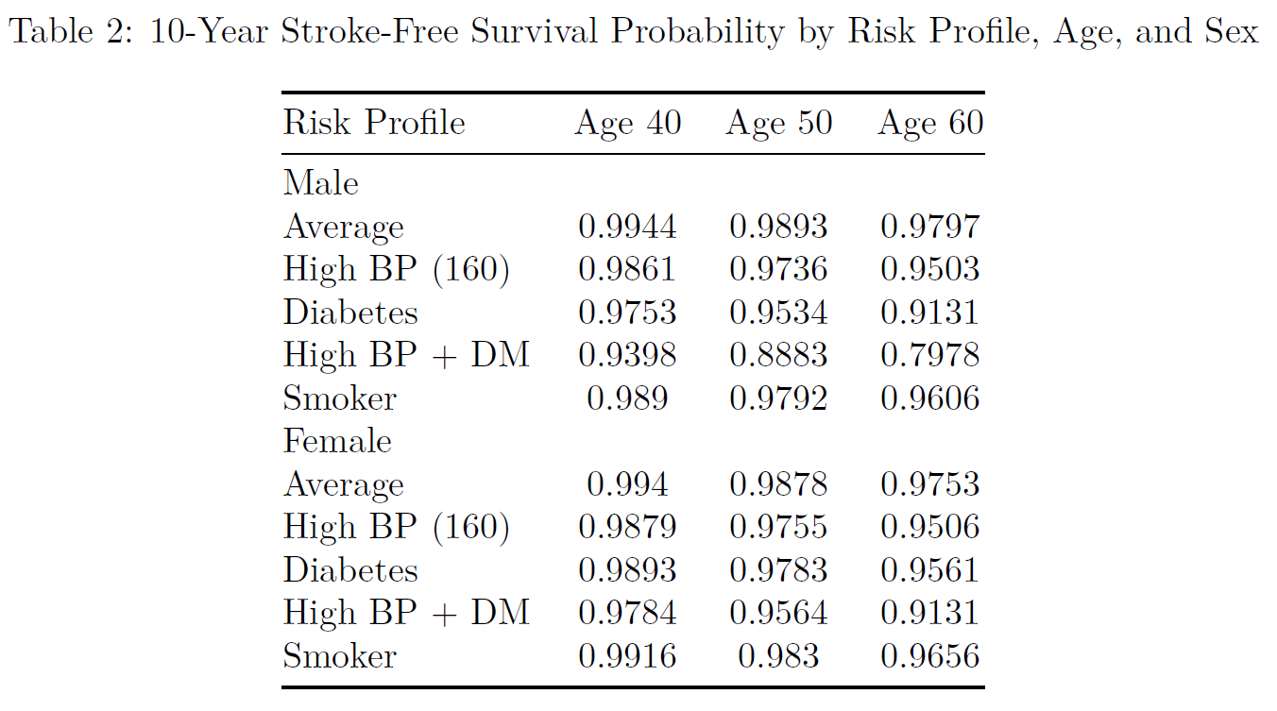
Primary Analysis
Unadjusted Kaplan-Meier curves stratified by sex showed similar stroke-free survival trajectories between males and females over the 10-year follow-up period, with both groups maintaining survival probabilities above 0.97 at 10 years (Appendix).
In the sex-stratified Cox proportional hazards models, systolic blood pressure and age were significantly associated with time to stroke in both males and females. Each one mmHg increase in systolic blood pressure was associated with a 3% increase in the hazard of stroke in both males (HR 1.03, 95% CI 1.02–1.04, p<0.001) and females (HR 1.03, 95% CI 1.02–1.04, p<0.001). Each one year increase in age was associated with a 7% increase in the hazard of stroke in both males (HR 1.07, 95% CI 1.03–1.11, p<0.001) and females (HR 1.07, 95% CI 1.03–1.12, p<0.001).
Diabetes was a significant predictor of stroke in males (HR 4.43, 95% CI 1.92–10.2, p<0.001) but was not statistically significant in females (HR 1.79, 95% CI 0.65–4.97, p=0.3), suggesting a possible sex difference in the association between diabetes and stroke risk. Similarly, current smoking was significantly associated with stroke in males (HR 1.96, 95% CI 1.05–3.65, p=0.035) but not in females (HR 1.40, 95% CI 0.81–2.42, p=0.2).
Estimated 10-year stroke-free survival probabilities across risk profiles are presented in Table 2. Among males aged 60 with both high blood pressure and diabetes, the estimated 10-year stroke-free survival probability was 0.7978, representing the highest risk profile across all groups. For the average risk profile, survival probabilities remained above 0.97 across all age groups and both sexes. The combined high blood pressure and diabetes profile consistently produced the lowest survival probabilities across all ages and both sexes, with probabilities declining markedly with increasing age.
Secondary Analysis
Risk factor distributions differed significantly across the three examination periods (Table 3). Mean age increased from 49.9 years in Period 1 to 60.6 years in Period 3 (p<0.001), reflecting the longitudinal aging of the cohort. Mean systolic blood pressure increased from 132.9 mmHg in Period 1 to 140.2 mmHg in Period 3 (p<0.001). The prevalence of diabetes nearly tripled from 2.7% in Period 1 to 7.8% in Period 3 (p<0.001). Conversely, current smoking prevalence declined from 49.2% in Period 1 to 34.4% in Period 3 (p<0.001). These substantial changes in risk factor levels across periods suggest that a time-varying covariate analysis may provide meaningfully different results and is worth consideration in future analyses.
Discussion/Conclusion
This analysis identified systolic blood pressure and age as consistent, statistically significant predictors of 10-year stroke risk in both male and female participants from the Framingham Heart Study. Diabetes and current smoking were significant predictors in males but not females, suggesting potential effect modification by sex for these risk factors. The estimated 10-year stroke-free survival probabilities demonstrate that the combination of high systolic blood pressure and diabetes represents the highest risk profile across all ages and both sexes, with risk increasing substantially with age.
The finding that diabetes was strongly associated with stroke in males (HR 4.43) but not significantly in females (HR 1.79, p=0.3) is notable, though the wide confidence intervals in both models, particularly in females, suggest limited statistical power to detect this association, likely due to the low prevalence of diabetes in the sample (2.7% at baseline). This result should be interpreted cautiously rather than as evidence that diabetes is not a stroke risk factor in women, which would contradict established clinical literature.
Several limitations of this analysis warrant consideration. First, the proportional hazards assumption was violated for diabetes status in both models, as indicated by non-random patterns in the Schoenfeld residuals. This means the hazard ratio for diabetes may not be constant over the 10-year follow-up period, and the reported hazard ratio represents an average effect over time rather than a time-specific estimate. A model incorporating a time-interaction term for diabetes would better capture this relationship and is recommended for future analyses. Second, the analysis relied exclusively on baseline risk factor measurements from Period 1. As demonstrated in the secondary analysis, risk factor levels changed substantially across the three examination periods, with systolic blood pressure and diabetes prevalence both increasing and smoking prevalence declining significantly over time. These changes suggest that a time-varying covariate analysis incorporating updated measurements from Periods 2 and 3 could meaningfully alter the estimated associations, particularly for variables like systolic blood pressure that showed consistent increases over time. Using only baseline values may underestimate the cumulative exposure to elevated risk factors for participants whose risk profiles worsened over follow-up. Third, complete case analysis was used for BP medication, which had 60 missing values. While this represents a small proportion of the sample, systematic missingness could introduce bias if those with missing BP medication data differ meaningfully from those with complete data.
In conclusion, systolic blood pressure and age are robust predictors of 10-year stroke risk in both sexes in this cohort. The substantial heterogeneity in estimated survival probabilities across risk profiles highlights the clinical utility of individualized risk estimation. Future analyses incorporating time-varying covariates and addressing the proportional hazards violation for diabetes would strengthen the validity of these findings.
Reproducible Research
GitHub link: https://github.com/asteinwand/BIOS6624.git
Data Path: "C:\Users\stein\OneDrive\Documents\School\2026 Spring\Advanced Methods\BIOS6624\Project 3\Data Raw\frmgham2.csv"

Appendix
